**Exercise 1: Control Structures**

**Scenario 1: The bank wants to apply a discount to loan interest rates for customers above 60 years old.**

* + **Question: Write a PL/SQL block that loops through all customers, checks their age, and if they are above 60, apply a 1% discount to their current loan interest rates.**
* **Code for this question is:**

create or replace procedure inc_interest IS

BEGIN

FOR result IN (

SELECT L.LoanID

FROM Customers C

JOIN Loans L ON C.CustomerID = L.CustomerID

WHERE MONTHS_BETWEEN(SYSDATE, C.DOB) / 12 > 60

FOR UPDATE

) LOOP

UPDATE Loans

SET InterestRate = InterestRate - (InterestRate * 0.01)

WHERE LoanID = result.LoanID;

END LOOP;

COMMIT;

DBMS_OUTPUT.PUT_LINE('1% interest discount applied to customers above 60!');

END;

**Output of the code:**

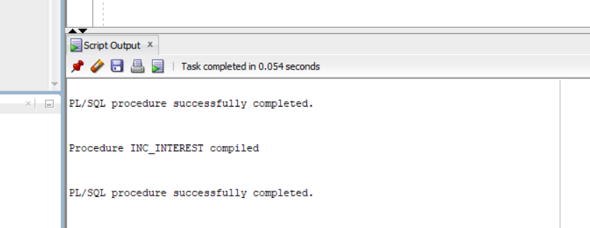

***Scenario 2: A customer can be promoted to VIP status based on their balance.***

* + **Question: Write a PL/SQL block that iterates through all customers and sets a flag IsVIP to TRUE for those with a balance over $10,000.**
* **Code for the problem:**

ALTER TABLE CUSTOMERS

ADD ISVIP VARCHAR2(5) DEFAULT 'FALSE';

BEGIN

FOR RES IN (

SELECT CUSTOMERID, BALANCE FROM CUSTOMERS

) LOOP

IF RES.BALANCE > 10000 THEN

UPDATE CUSTOMERS

SET ISVIP = 'TRUE'

WHERE CUSTOMERID = RES.CUSTOMERID;

END IF;

END LOOP;

COMMIT;

END;

**Output of the code:**

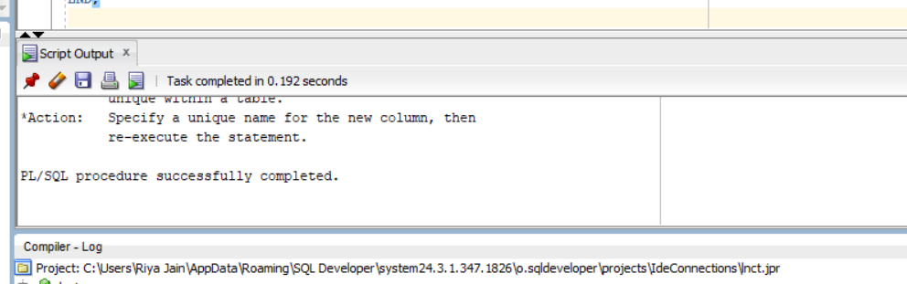

***Scenario 3: The bank wants to send reminders to customers whose loans are due within the next 30 days.***

* + **Question: Write a PL/SQL block that fetches all loans due in the next 30 days and prints a reminder message for each customer.**
* **Code of the problem:**

create or replace procedure reminder IS

BEGIN

FOR res IN (

SELECT C.NAME, C.CUSTOMERID, L.LOANID, L.ENDDATE

FROM LOANS L

JOIN CUSTOMERS C ON L.CUSTOMERID = C.CUSTOMERID

WHERE L.ENDDATE BETWEEN SYSDATE AND SYSDATE + 30

) LOOP

DBMS_OUTPUT.PUT_LINE(

'Reminder: Customer ' || res.NAME ||

' (ID: ' || res.CUSTOMERID || ') has a loan due on ' ||

TO_CHAR(res.ENDDATE, 'YYYY-MM-DD')

);

END LOOP;

END;

**Output of the program:**

